Mold It, Make IT, and Take it: Creating Custom Buttons

Instructor: Denise Pinell

March 8, 9:00 am – 12:00 pm - $30. Location: Holiday Inn Express, 1661 Villa Cardiff Dr, Cardiff

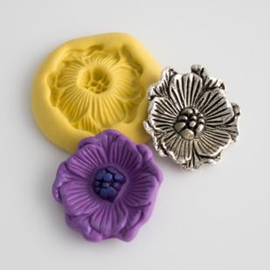
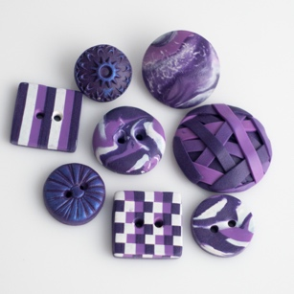
Are you always struggling to find the perfect button to compliment your latest creation? Always finding the right shape in the wrong color or right color in the wrong shape? In this class, you will learn how to make simple textured and patterned buttons, buttons from molds and even create a mold from your favorite button! Participants will receive an introduction to polymer clay, instructions on how to consider clay color selection and condition clay for project use. We will then apply step by step instructions for simple clay techniques to create several patterned and textured buttons, seeing what different effects can be obtained using just 3 colors of clay.
Level of Experience: All levels welcome.
Homework: Please bring with you your favorite shape button and/or a button-sized object (charm, pin, bead, etc.) that you would like to make into a button for mold making and creating custom buttons (a few objects will be available in class). You might like to identify a knitted piece with your favorite colors so this piece can serve as inspiration for your in-class creation.
Materials:
Each participant will receive a starter kit for creating buttons, a selection of clay colors will be available for you to choose at the workshop. Other materials to finish your piece will be provided by the instructor. There will be several pasta machines (for conditioning the clay) and two ovens for baking participants’ clay pieces.
If you have round nose piers, wire cutters or a craft knife please bring them with you. If you have experience in working with polymer clay and your own tools, please bring your pasta machine, work surface, Plexiglas roller and whatever other items you prefer (favorite texture sheet etc.)
Materials fee: $8
How to Register: Sign up at the January Guild meeting or send an email to Programs@SanDiegoKnitters.com. Be sure to include your name, the name of the workshop, your email address and a telephone number.
To learn more about Denise’s visit to the Guild, see Knitters Meeting Calendar
To learn more about Denise, visit www.denisepinnelldesigns.weebly.com

